

MARKETING WEBSITE

**SUBMITTED BY-**

ADITYA (12308561)

AADITYA RAJ (12324412)

LOVESH ROY (12323021)

**SUBMITTED TO-**

MR. RAJAN KAKKAR

**COURSE CODE:** CSE-326

**Internet Programming Laboratory**

**SECTION –** K23TO

**DATE –** 15-11-2023

**TABLE OF CONTENTS**

Page No.

1. Acknowledgement ……………………………. 3
2. Abstract...……………………………………... 4
3. Introduction …………………………………... 5
4. Technologies ....….….………………………… 6
5. Modules ………….…………………………… 7
6. Website ……………….………………………. 8
7. References ……………………………………. 13

**ACKNOWLEDGEMENT**

The successful completion of this project report would not have been possible without the support and assistance of many individuals and organizations. We would like to take this opportunity to offer our earnest admiration to every one of them.

We express our sentiment of gratitude to Mr. Rajan Kakkar sir, who has been a continuous source of inspiration as our teacher. Without his constant guidance and suggestions, this report would have been nowhere near completion. Our gratitude for his trust and generosity goes beyond words.

Thanks to our classmates who helped us directly or indirectly to accomplish our work. Finally, we thank all the teachers who prepared us for this endeavor. We owe you all for this success.

**ABSTRACT**

This project involves the creation of a marketing website using **HTML** and **CSS**, titled "**MailChamp**" Learning HTML structure and styling it with CSS were the main objectives of this project. To create a Marketing Website project, we need to know the basics of HTML and CSS. For this project we have used VS-Code as the Integrated Development Environment.This report takes us through all the details of **Website Design** knowledge and experience gathered during this project.

**INTRODUCTION**

From a dynamic header and achievements section to informative articles on email effectiveness, the website aims to offer a user-friendly experience. It has various parts like a header with navigation, a section about achievements, and articles on using emails effectively. The achievements’ part talks about support and app integrations. In the articles, you can learn about email automations, AI content creation, and audience targeting. The website also has a footer with contact details and organized links.

Explore the features that make “MailChamp” a valuable tool for email marketing. We focused on making it easy to use and visually attractive to promote “MailChamp's” services.

**TECHNOLOGIES**

**HTML5-**

HTML, or HyperText Markup Language, is the standard language for creating and designing web pages. It uses a markup structure composed of tags to define the various elements on a webpage, such as headings, paragraphs, links, images, forms and more. HTML provides the basic structure for web content.

For this Website, **HTML5** for its basic structure was used as it is the main component of any webpage.

**CSS3-**

CSS, or Cascading Style Sheets, is a stylesheet language used for describing the presentation of a document written in HTML or XML. It enables web designers to control the layout, colors, fonts, and other visual aspects of a webpage. It plays a crucial role in separating the structure of a webpage (managed by HTML) from its presentation, enhancing flexibility and maintainability in web development.

We have used **CSS3** for all the styling of this webpage, from the background-colors to the visually appealing transformations when hovering with the mouse cursor on an element.

**JAVASCRIPT-**

JavaScript, often abbreviated as JS, is a versatile programming language commonly used for web development. It enables interactive and dynamic content on websites. As a client-side scripting language, it runs in web browsers, allowing developers to manipulate the Document Object Model (DOM) and respond to user actions. JavaScript is essential for creating features like form validations, interactive forms, dynamic content updates, and more.  
  
We have only used little **Javascript**, which is only in the input search bar. When entered with a prompt, it returns a Google search output in a new tab of the browser.

**MODULES**

1. **Header and Navigation:** The website features a dynamic header with the MailChamp logo and a user-friendly navigation menu.
2. **Achievements Section:** In this section, the website highlights MailChamp's achievements, including award-winning support and a robust app integration ecosystem.
3. **Articles:** The main content area presents articles focusing on leveraging MailChamp for effective email marketing. Each article delves into specific features, such as email automations, generative AI content creation, and advanced audience segmentation.
4. **Footer:** The footer provides essential information, including the company's location address and contact details.
5. **Organized Footer Links:** This module organizes footer links into categories like Products, Resources, Community, Company, and Help. Each category contains relevant links, enhancing user accessibility to several aspects of MailChamp's offerings and support resources.
6. **“MailChamp Presents” Section:** This unique module highlights "MailChamp Presents," featuring films, podcasts, and original series celebrating the enterprising spirit.

**WEBSITE**

Starting with the header

The header of the Webpage is like any other modern sites which have the clickable logo of the company.

Then the navbar which allows users to hop to different sections without scrolling up and down.

On the far right we have the search bar which allows the user to search up anything. We also add an additional/optional feature in the search bar that when prompted with an input it searches that on the Google search results by opening that in a new tab in the browser.

The header also has the position: sticky; property in its styling part to stick it to the top of the webpage even after scrolling down.

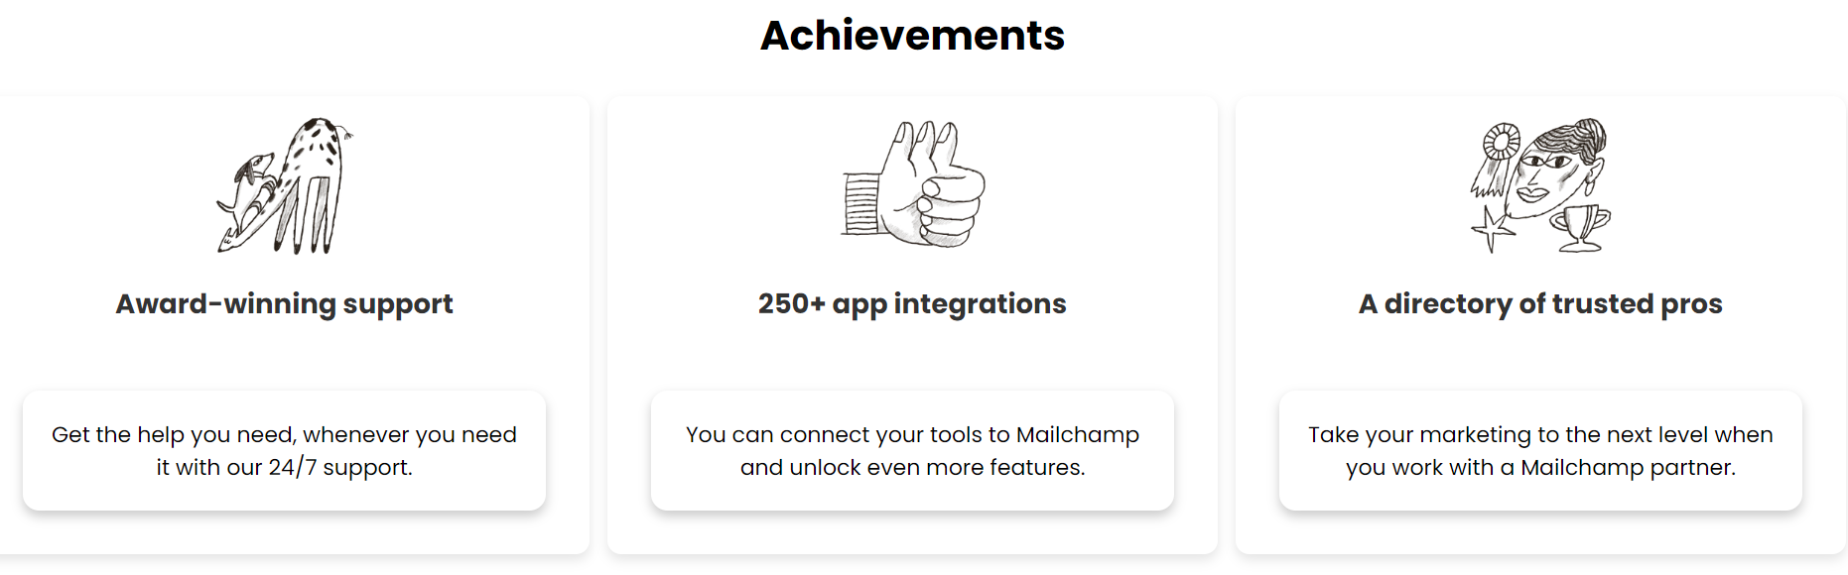Next, we have the Achievements section,

We highlighted the achievements of the company to build the trust of the clients and applied CSS for visually appealing exoticness.

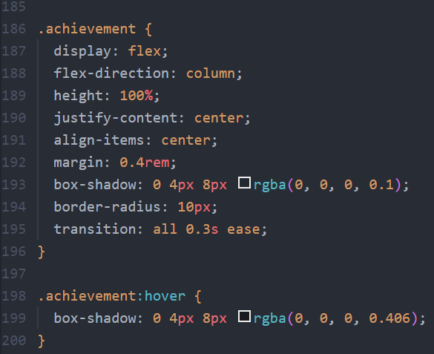The box-shadow property has been used for all the div tags that have been used in the webpage.

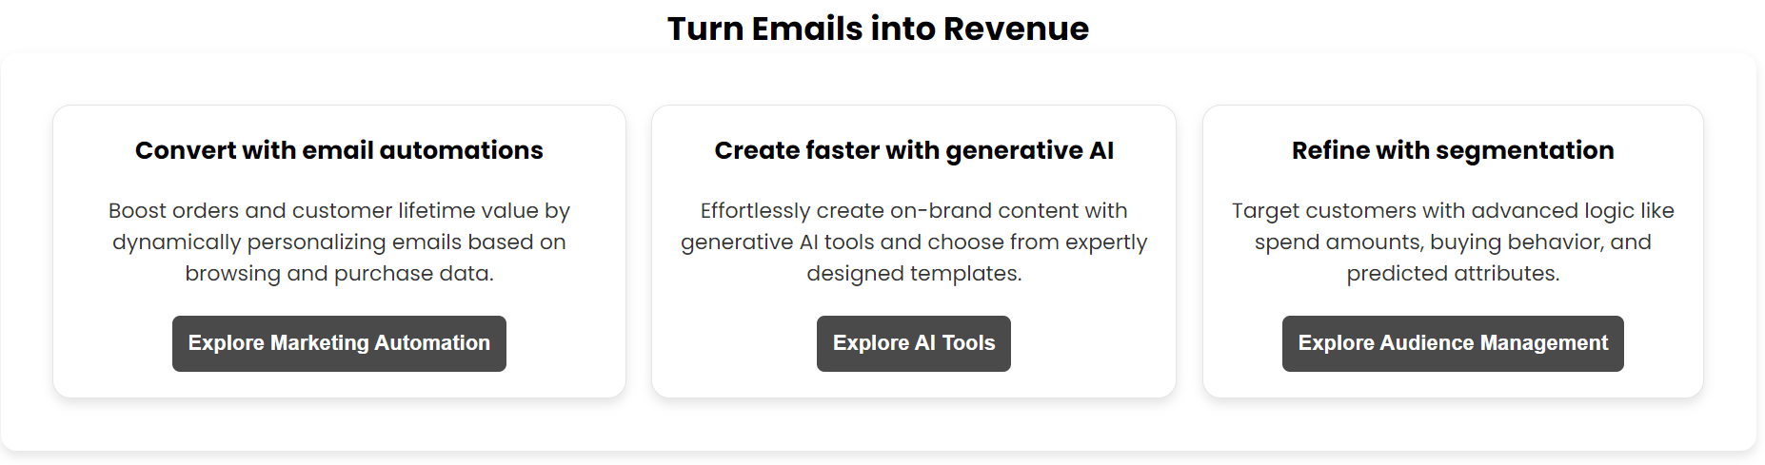Next up, we have the about us section where we have displayed major articles of the company.

You can see the box shadow in each of the div-containers for the text placement and the buttons.

The buttons itself has decent styles on it. Every button has the same style to keep the theme throughout the whole webpage.

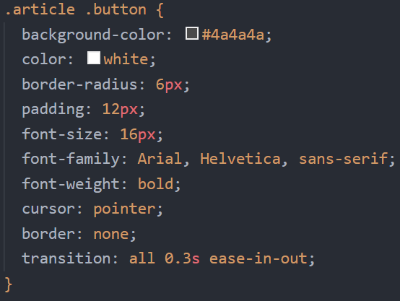Create these appealing buttons, we have applied the following styles.

At last, but not the least, we have the footer itself which have the required information like Location Address and Contact Details.

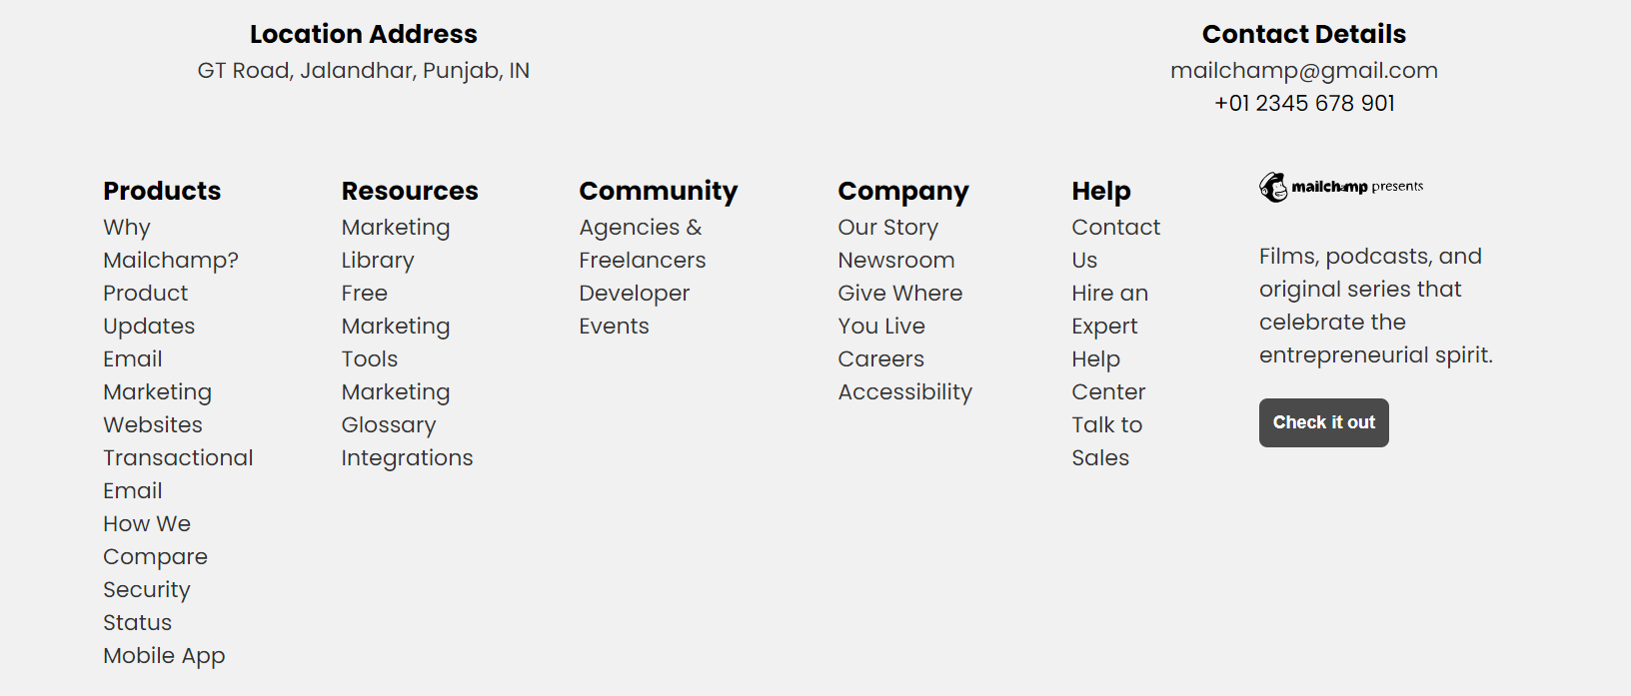

In this we also have the various navigation links.

Also, there is one CTA (Call to Action) button on the right side of the footer which have the same styles that were on the About us section buttons.

By this, we have covered all the aspects of the modern-day Marketing Webpage Design.

Thank You

**REFERENCES**

1. Inspired by MailChimp ([https://mailchimp.com](https://mailchimp.com/?currency=INR))
2. YouTube ([Header Tutorial](https://www.youtube.com/watch?v=CgxEA9iMMWI)), ([Search Bar](https://www.youtube.com/watch?v=9hnJsNIBq1g)), ([Footer](https://www.youtube.com/watch?v=lLdzlLL33G8))
3. GeeksforGeeks ([Flex Box](https://www.geeksforgeeks.org/introduction-to-css-flexbox/)), ([Flex Property](https://www.geeksforgeeks.org/css-flex-property/))
4. w3schools ([https://www.w3schools.com/](https://www.w3schools.com/css/css3_buttons.asp))
5. Google Gen AI ([marketingwebsite.com](https://www.google.com/search?q=marketing+website&oq=marketing+website&gs_lcrp=EgZjaHJvbWUyCQgAEEUYORiABDIICAEQRRgnGDsyCAgCEEUYJxg7MgcIAxAAGIAEMgcIBBAAGIAEMgYIBRBFGDwyBggGEEUYPTIGCAcQRRg90gEIMzMxOWowajGoAgCwAgA&sourceid=chrome&ie=UTF-8))
6. ChatGPT Ideas (<https://chat.openai.com/>)
7. FreeCodeCamp ([Basic HTML](https://www.freecodecamp.org/news/html-crash-course/)), ([CSS](https://www.freecodecamp.org/news/css-crash-course/))
8. Web-eau ([Footer Design](https://web-eau.net/en/blog/10-best-footer-html-css-snippets))